Charles Williams Church in Wales Primary School
Prospectus Additional Information

Headteacher: Miss Rebecca Penn

Deputy Headteacher: Mr James Llewellyn
Leader for Learning Foundation Phase – Mrs Kathryn Sperry
Leader for Learning Key Stage 2 – Mr Adam Cornes

Chair of Governors: Mrs Carolyne Benavides
Vice Chair: Mr Stephen Marshall

Welcome

Welcome to Charles Williams Church in Wales Primary School. Our historic school was founded in 1724 by Charles Williams, a wealthy Londoner who was born and spent his early years in Caerleon. He decided that he would like to endow a school where, free of charge, the poor children of Caerleon would be taught the principles of Christianity and be ‘taught such other things as are most suitable to their condition’.

After these humble beginnings with just 30 boys and 30 girls the school has continued to flourish and grow. We now have around 600 pupils from the age of 3 to 11 across Nursery, Foundation Phase and Key Stage 2.

It is safe to say that the things most suitable to the condition of the children have changed quite considerably over the prevailing 300 years but the principle remains the same: we work tirelessly to ensure every child reaches their full potential; that we provide an inspiring educational experience; that our Christian values are reflected in all that we do and that every child leaves us with a sense of pride and respect for our school and our community.

Thank you for choosing or considering us as the place that you trust to look after your child.

Miss Rebecca Penn
Headteacher
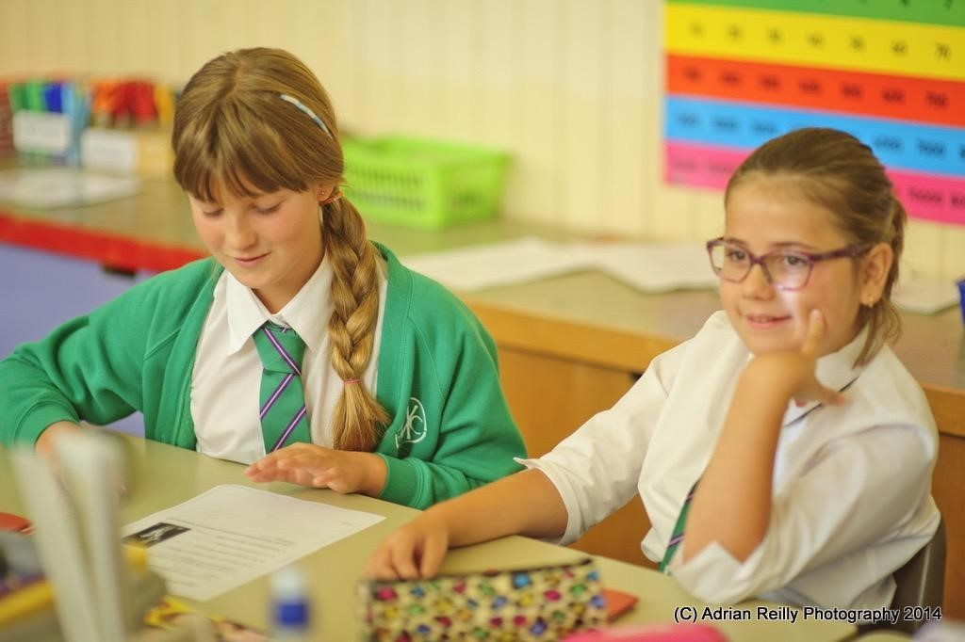

Staff

Chair of Governors – Mrs C Benavides

Teachers Teaching Assistants
Mrs K Sperry Mrs K Rackham
Mrs S Brindley Mrs V Jones
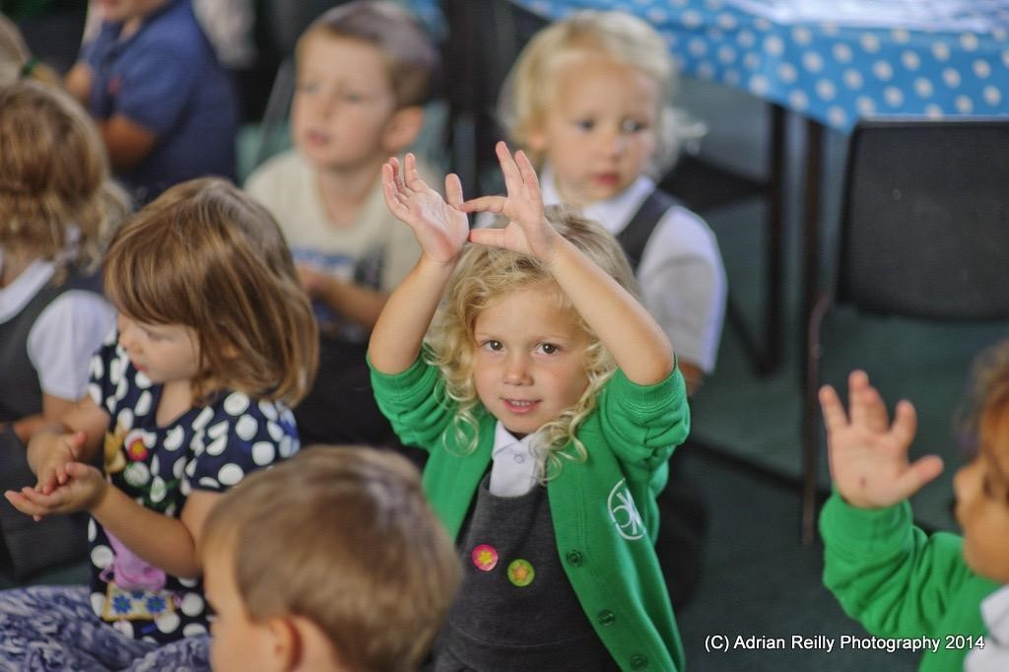
Miss L Hickman Mrs C Bishop
Miss M Kent Mrs D Davies
Mrs H Armstrong Mrs L Jenkins
Mrs E Furtek Miss T Hughes
Miss R Kendall Mrs J Aitken
Mrs E James Miss T Guest
Mrs A Price Miss E Masterton
Ms S Price Mrs E Rosen
Mr M Davies Miss C Toms
Mrs T Tew Mr R Lloyd
Mrs C John Mrs S Norvill
Mr M Andrews Mrs L Ball
Mrs K Clement Mrs K Dumina
Mr A Cornes Mr S Green
Miss A Hyde Ms J Nutman
Mrs R Cooper Mrs C Hard (HLTA)
Ms A Casa Grande Miss E Jones (HLTA)
Mr J Llewellyn

Administrators Site Managers
Mrs R Penfold Mr A Dunn
Mrs C Trott Mr R Mann
Mrs N Smith

Admissions
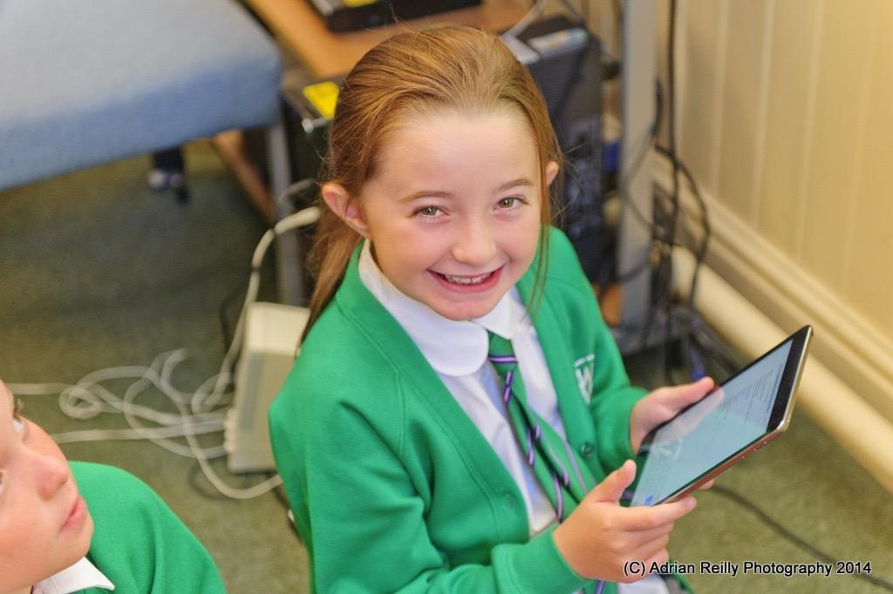
Charles Williams Church in Wales (CiW) Primary School is a Voluntary Aided School.

Application forms should be obtained from the school and returned to the Mrs R Penfold (admissions administrator).

Responsibility for admission decisions lies with the school’s Governing Body, who delegate this duty to a small sub-committee. The school liaises closely with the Local Authority to co-ordinate closing dates for applications and sending offer letters to families.

Children currently attending the Nursery must complete a school application form to apply for a place in the reception class and will be treated in the same way as all other applications. Attending Nursery does not guarantee an offer of a place in Reception at school.
The school and nursery’s admission policy can be found on the school’s website.

School Health Service

All parents/carers are asked to provide the school with emergency contact details and medical details relating to their child. It is imperative that these are kept up-to-date; the school needs to be informed of any change of circumstances. Where parents live separately both addresses should be supplied so that information can be given to both parties if required.

Medicine - Unfortunately, staff at the school are unable to administer any medicine unless your child has a specific and on-going medical condition when a health care plan is set up between the school, outside agencies and parents/carers. If your child needs to take medication but the doctor has said that he or she is well enough to attend school, you may visit the school at lunchtime to administer the medicine yourself. (Antibiotics that need to be taken four times a day can be administered by a member of staff following completion and receipt of appropriate consent forms).

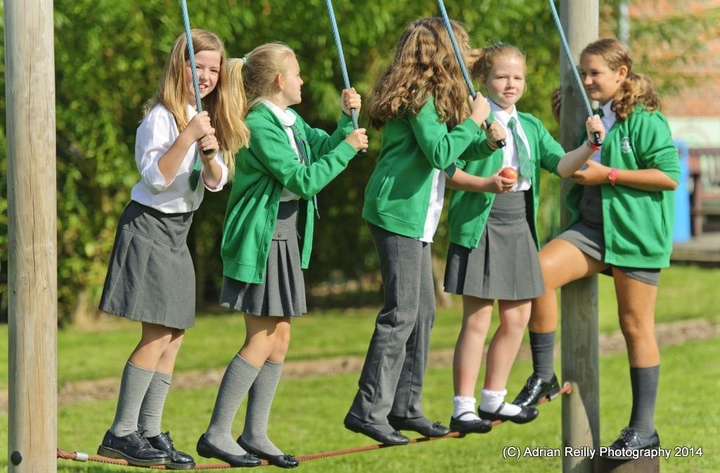
Asthma - If your child suffers from asthma and needs an inhaler, please ensure that your child has a clearly marked pump in school everyday and that your child's class teacher is aware of this. Children who suffer from asthma will not be permitted on school trips without their inhaler. The school should be advised of any changes with this condition.

Allergies - If your child has a serious allergy, such as a nut or egg allergy and requires specific treatment should this allergy be triggered, it is imperative that you share this with the school. We are a nut aware school – parents are asked and reminded not to send food into school that contains nuts.

Illnesses and Accidents - If your child is taken ill at school, we will telephone you immediately. It is very important therefore that the school has up to date contact details for you.

Despite our best efforts, accidents do sometimes happen during school activities. If your child does have an accident, their condition will be assessed. In cases of minor injury, your child will be treated immediately and you will be sent a note explaining what has happened and the nature of the injury. If your child bumps his/her head at school parents/carers will always be informed regardless of how minor this is.

If we feel that your child needs treatment that we cannot provide, or if it is preferable for them to go home, you will be notified immediately. They will be cared for until your arrival. In the rare case of emergency situation, it may be necessary to take your child for treatment at the hospital; an ambulance will be called immediately. You will also be called at this time. If, however for some reason we are unable to contact you or you are unable to accompany your child in the ambulance, we do seek prior permission (when your child first enters school) for us to take your child to the hospital and remain with your child until we are able to hand over duty of care to you.

In line with Public Health advice, in order to prevent the spread of contagious illnesses, children contracting certain illnesses e.g. sickness bug, should remain absent from school until 48 hours after the last bout of illness. If your child has any form of infectious illness, and you are unsure of whether or not they should attend school, you should consult your doctor or the school for more advice. Please note, our management of Covid-19 is reviewed regularly and is shared with parents and carers.

Absences - Good attendance at school is vital to your child's progress at school. If your child is away from school due to illness, you are asked to telephone, or email the school so that the class teacher can be informed. If you have not contacted the school, on returning to school after an absence, your child will need to bring a note to his/her teacher. Such absence will therefore be recorded as authorised. You are encouraged to make dentist and doctor's appointments for your child after school hours. However, if this is not possible, we should be grateful if you could inform us prior to the absence.

Holidays - Holidays in term time are only authorised in exceptional circumstances. As with all absences, please inform us of holidays by completing a notification of absence form or via the absence reporting function in the ParentMail app. Please see the attendance policy for further information.

Relationships and Sexuality Education

At Charles Williams CiW Primary School we believe it is important to provide a comprehensive, coherent and well planned programme of health, relationships and sexuality education to help pupils cope with their physical, emotional and social development. This programme of learning is based on the objectives and learning outcomes which are a statutory part of the Curriculum for Wales. All aspects of the curriculum are age-
appropriate.

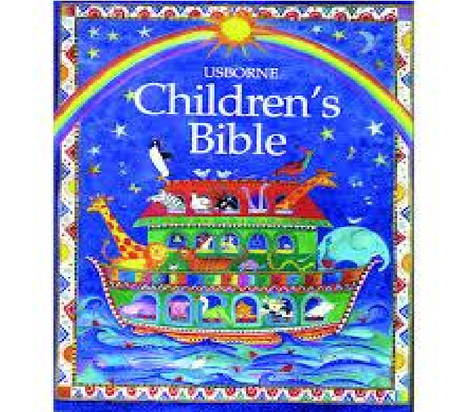
Religious Education

Religious Education and collective worship are at the heart of Charles Williams CiW Primary School. Christian values underpin the ethos of the school and we aim to reflect the Christian gospel in all we do. We aim to ensure that our pupils learn about a living faith which emphasises the need to care and share.

With the support of the parents, the Governing Body of the school has agreed for Religious Education to be taught in accordance with the principles and practice of the Church in Wales.

We endeavour to help our pupils to develop a sense of self-worth and personal responsibility which will enable them to take an active and responsible part in society. Children are introduced to other faiths.

Additional Learning Needs (ALN)

The school is committed to the inclusion of children with additional learning needs. We recognise that early identification and appropriate intervention is paramount. All pupils, including pupils with ALN, will have access to a broad, balanced curriculum. Pupils’ views on their learning are valued and are considered. Parents have a vital role in supporting their child’s education and, therefore, partnership with school is promoted. Mrs E Furtek is the school’s Additional Learning Needs Manager.

Equal Opportunities

Charles Williams CiW Primary School is committed to working towards equality regardless of disability, race, gender, age, faith, sexual orientation and language, and to the creation of an inclusive culture in which every individual, regardless of ability and background is enabled to participate and is valued as a member of the school community.

We therefore promote positive approaches to difference and foster respect for people of all cultural backgrounds. We ask that all visitors to our school respect our commitment. Our school complies with all aspects of discrimination law, by ensuring that principles of fairness and equality are applied in everything that the school does.

Disability Equality

We seek to remove barriers to learning and participation. We aim to provide every pupil with the opportunity to reach their full potential. We welcome, encourage and support disabled pupils by:
- promoting equality of opportunity;
- eliminating discrimination;
- promoting positive attitudes;
- encouraging participation, and,
- taking steps to meet individual needs.

School Uniform

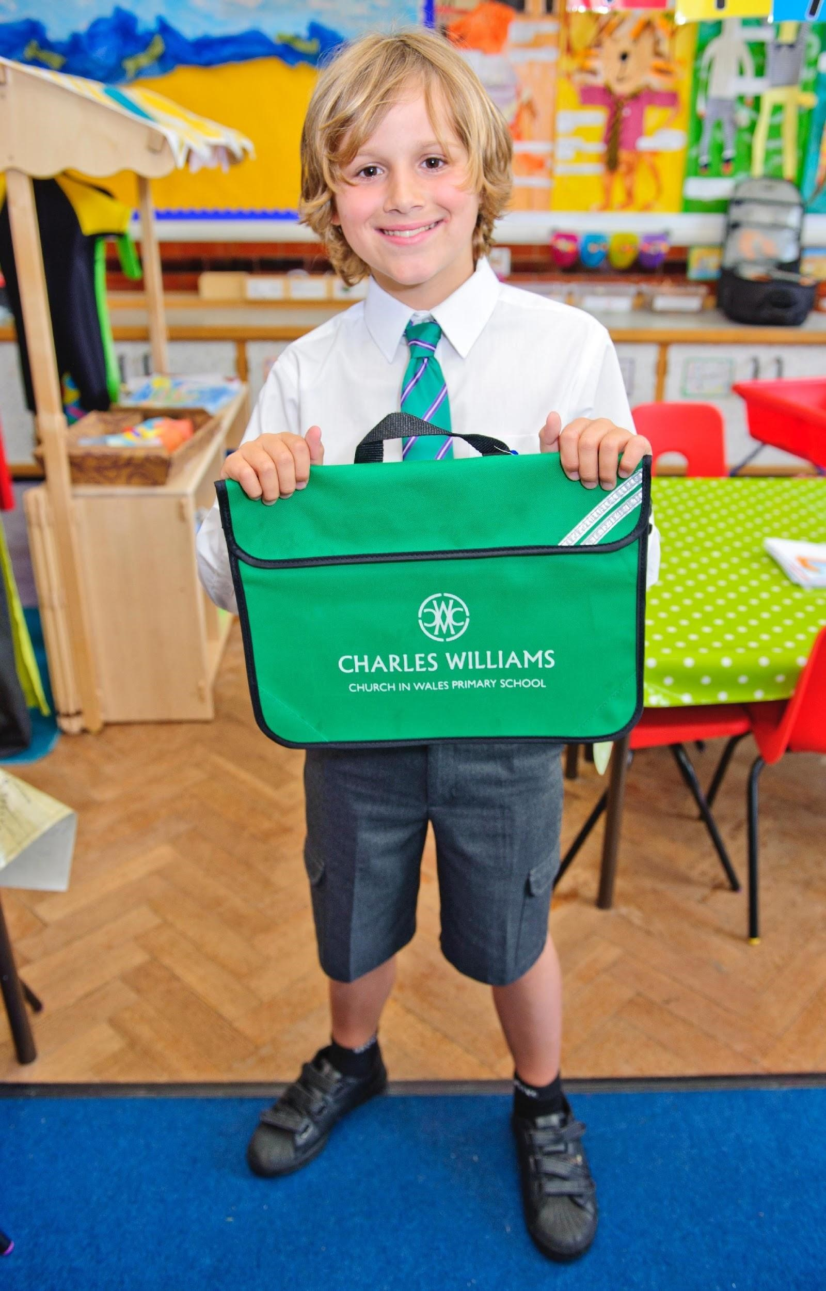
Our uniform is practical and comfortable and gives children a sense of pride in belonging to the school community. The official school uniform, with the school logo, is available from Macey Sports on Caerleon Road and Pretty Miss in Cwmbran. It is not compulsory for clothing to have the school logo.

The school uniform consists of:

- green jumper/cardigan;
- grey trousers/skirt/pinafore/culottes;
- black shoes or plain black trainers (until children can tie their laces, please consider Velcro fasteners);
- Nursery to Year 2 – white polo shirt; and,
- Year 3 to Year 6 – white shirt with school tie

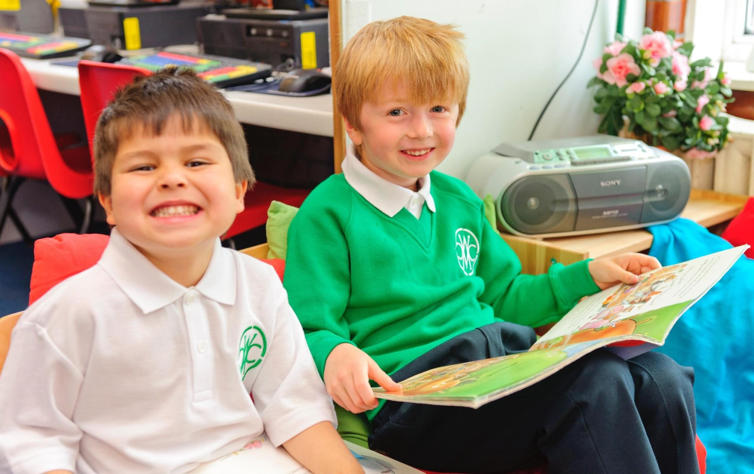
Summer Term only
Summer dress/shorts/skirts/culottes/playsuits in green check or stripe, grey shorts.
Year 3 to Year 6 - shirts and ties may be replaced with school polo shirts.

PE kit – black shorts with white round neck T-shirt, black daps/trainers. In winter, black jogging bottoms and a green hooded top may be worn.

No jewellery with the exception of stud earrings – no hoops or hanging earrings.
Discreet hair clips/bands.
Term dates

School Year 2022/2023
Term | Start | Half-term starts | Half-term ends | Term ends
Autumn | 2 Sept 2022 | 31 Oct 2022 | 4 Nov 2022 | 23 Dec 2022
Spring | 9 Jan 2023 | 20 Feb 2023 | 24 Feb 2023 | 31 March 2023
Summer | 17 April 2023 | 29 May 2023 | 2 June 2023 | 21 July 2023

School Day

Nursery
Morning Session 9.00 am until 11:30 am (doors open at 8:50 am)
Afternoon Session 12:45 pm until 3:15pm

Reception to Year 2

Day starts – 9.00 am Lunch – 12.00 pm to 1.00 pm Day ends – 3.15 pm

Year 3 to Year 6

Day starts – 8.55 am Lunch – 12.00 pm to 12.50 pm Day ends – 3.15 pm

School Meals
Children may bring a packed lunch or pay for a lunch which is served in our dining hall and supervised by our team of lunchtime supervisors. Newport City Council and school catering contractors, Chartwells, aim to ensure that every pupil in school in Newport is able to receive a nutritious, freshly cooked, affordable main midday meal each day.

Free school meals - Families who claim certain benefits are eligible to receive free school meals. For more information on school meals, or how to access free school meals, please contact Mrs C Trott (school administrator – mrs.trott@charleswilliamsprimary.org).

Lunch - A hot main meal plus dessert is provided, along with an option for pupils who have a vegetarian or halal diet. We hope to also be able to provide a jacket potato and two cold lunch options. If your child has food allergies and is likely to have school meals, please contact Mrs C Trott.

A selection of vegetables is always available as is fresh fruit, yoghurt and cheese.

Water is freely available at lunchtime.

Milk - All pupils from nursery to Year 2 receive one third of a pint of free milk daily. Please inform your child’s class teacher if your child does not want or cannot drink milk – water will be provided instead.

Price - A main meal plus dessert in primary school costs £2.15 and is payable via ParentPay.

Free Breakfast – A limited number of places are available. Breakfast is served between 8.15 am and 8.55 am. Please contact Mrs R Penfold for access to an application form: PenfoldR7@newportschools.wales

Nut Aware – We are a nut aware school. Several children and a staff member have life-threatening allergies to nuts. We politely ask that foods containing nuts are not brought into school.

Start and End of the School Day

All gates open at 8.45 am. The main gate (opposite the office) and the gate at the rear of the staff car park closes at 8.55 am. The main gate is locked at 9.00 am.

For the safety of pupils and parents/carers, football is not allowed before school starts and we politely ask that children who scoot or cycle to school wheel their scooters and bikes across the yard.

It is of utmost importance that your child arrives punctually and in time for the beginning of the school day. This ensures that your child is settled in time for learning. The class register is taken immediately upon arrival and learning starts promptly at this time. Any child arriving late must be signed in by parents/carers at the main reception area of the school and a 'late' mark is recorded in the register. Children arriving 30 minutes after the registers have closed will be marked as unauthorised unless we have been given prior notice of, e.g. medical or dental appointments. Persistent lateness can result in a fixed penalty charge.

At the end of school, parents/carers are also requested to wait on the appropriate yard for the children to be dismissed from their class. Pupils from nursery to Year 2 will not be allowed to leave until an authorised person is there to collect them. If there are any changes to your usual end of day arrangements, please contact the school to inform us. The safety of your child is of utmost importance to us.

It can be very busy outside our school at the beginning and end of the school day. Please take great care and park clear of the school’s main entrance. The safety of all our children is of greatest importance. Please drive carefully and park courteously. Parking in the school car park is strictly for staff only.

You are very welcome to come and speak to your child’s class teacher as needed. Please remember that after school is the best time, as the teacher has his/her class to look after at the beginning of the school day and, therefore, they are not available. Your co-operation would be most appreciated in this matter. Please also note that you can contact the class teacher via email, an up to-date list is on the school website. Staff aim to reply to emails within a week.

Safety
The health and safety of your child if of prime concern; to this end we have put the following measures in place:
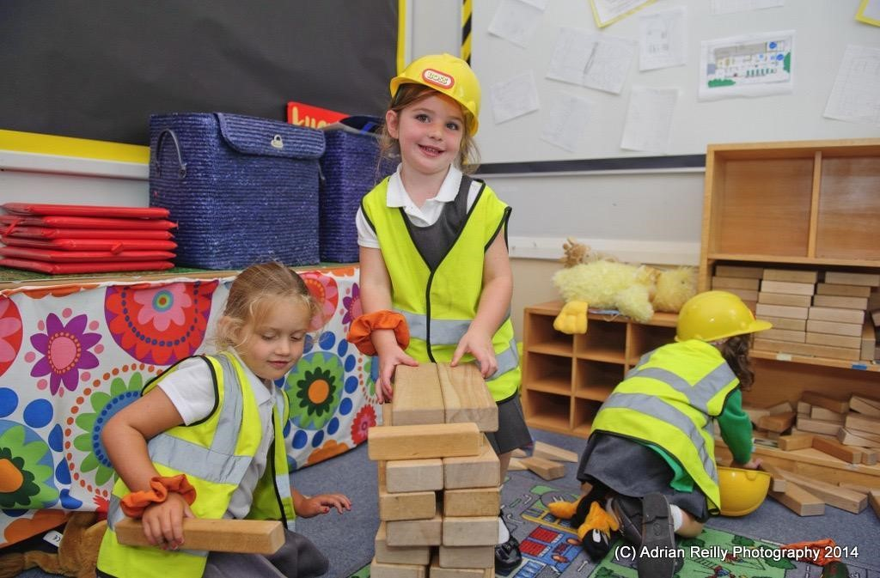
The school gates are locked at either 8.55 am or 9:00 am and admission to the site after this time is only possible through the gate at the main entrance. Should you wish to enter during the school day, please report to the main entrance, and a member of our administration team will be happy to help you.

Children leaving school for medical or other necessary appointments must be collected by you or an adult that is known to the school who will need to sign your child out. Please inform the school beforehand should you wish to take your child to an appointment.

When collecting children from an afterschool club, please collect from the front of the school so that children can be dismissed by staff to a parent/carer.

Fire Drills are held on a termly basis and alarms are tested weekly.

For health and safety reasons, dogs are not permitted on the school premises. Assistance dogs are of course an exception.

Staff and governors undertake regular training in safeguarding issues, including child protection.

As directed by the Local Authority, if we have concerns about a child’s welfare, we will contact parents and refer to the appropriate authorities. However, if the concerns are significant enough, we may not communicate with parents until the matter has been investigated.

Please see the school’s Child Protection Policy if you require further clarification.

Home-School Agreement
In setting our aims and objectives we fully appreciate that our success depends on us working in partnership with all parents/carers for the benefit of the children. Each of us has responsibilities and expectations and, to this end, we have drawn up a Home-School Agreement which we would ask all parents/carers to consider and sign. A copy of the agreement is given to all parents/carers of new pupils as they join the school.

Welsh
Welsh as a second language is taught to all pupils. The language is taught in a variety of ways including focused lessons, incidental and regular use of the language during the school day as well as songs, stories and rhymes.

Incidental Welsh
We actively encourage children, staff and visitors to use the Welsh language in all aspects of school life, including break times. We aim to develop an enjoyment of learning our national language and to value its importance in terms of our cultural identity.

Curriculum Cymreig
The Curriculum Cymreig is a part of the curriculum that is special to Wales. It is designed to reflect the history, geography and culture of Wales and our local community.

The Curriculum Cymreig helps develop:
- a sense of belonging;
- a sense of place and heritage;
- an awareness of the importance of language and literature in the history and life of Wales, and,
- an understanding of the creative and expressive arts in Wales.

Complaints Procedure
Any parent wishing to lodge a complaint about the organisation and/or content of the curriculum (under section
23 of the Education Reform Act 1988) is asked to follow the following procedure;

9 a) Notify the Headteacher of the complaint, it will then be investigated and a response made.

(b) If you are not satisfied with the response then notify, in writing, the chairman of the governing body. The governors will investigate your complaint and respond to it.

Please visit the website or ask for a full copy of the complaints policy if needed.
Parents and carers are respectfully asked not to use social media to air concerns or complaints as this is not school procedure and can cause problems for the school, other parents or pupils. We ask parents to work with us to resolve any problems.

Address: High Street, Caerleon, NP18 1AZ
Email address: charleswilliams.primary@newportschools.wales
Telephone: 01633 423497
Web Site: www.charleswilliamsprimary.org
Twitter: @cwprimary

